Given two numbers, hour and minutes. Return the smaller angle (in sexagesimal units) formed between the hour and the minute hand.

**Example 1:**

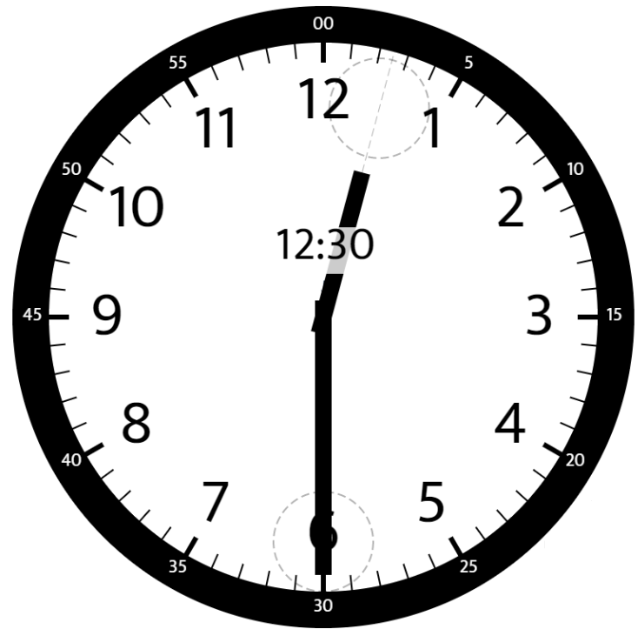

**Input:** hour = 12, minutes = 30

**Output:** 165

**Example 2:**

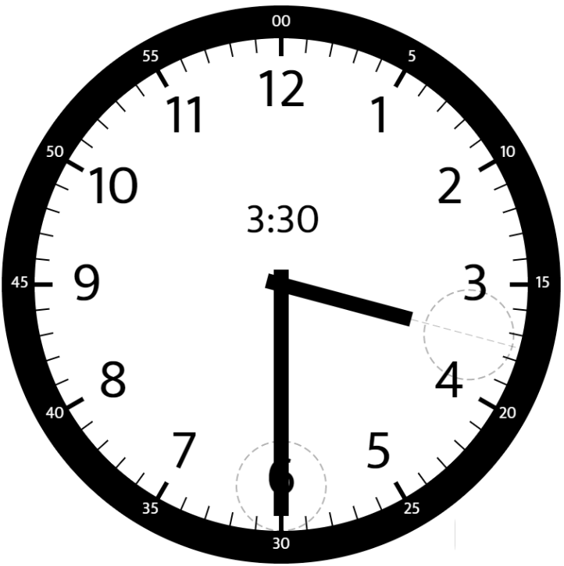

**Input:** hour = 3, minutes = 30

**Output:** 75

**Example 3:**

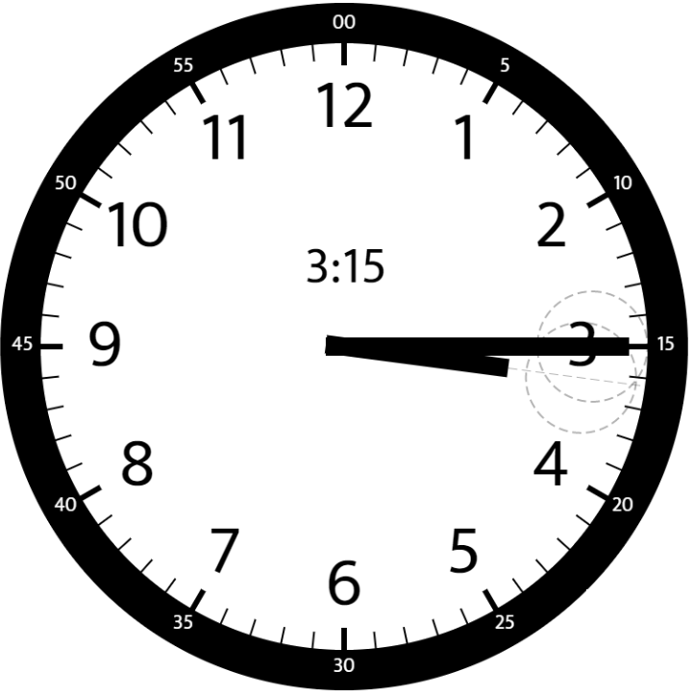

**Input:** hour = 3, minutes = 15

**Output:** 7.5

**Example 4:**

**Input:** hour = 4, minutes = 50

**Output:** 155

**Example 5:**

**Input:** hour = 12, minutes = 0

**Output:** 0

**Constraints:**

* 1 <= hour <= 12
* 0 <= minutes <= 59
* Answers within 10^-5 of the actual value will be accepted as correct.